**Part 2: Hosting a Static Portfolio Website on S3**

**Objective**: Learn to host a static website (such as a personal portfolio) on Amazon S3.

**Approach**:

**1. Create an S3 Bucket**: Start by creating a new S3 bucket. Configure the bucket for website hosting, which includes setting permissions to make the content publicly accessible.

**2. Upload Website Files**: Upload the static files of your portfolio website (HTML, CSS, JavaScript, images) to the S3 bucket.

**3. Configure DNS:** Use Amazon Route 53 or another DNS service to point a domain name to the S3 bucket. This makes the website accessible via a user-friendly URL.

**4. Enable Additional Features (Optional):** Implement features like HTTPS for secure access and CloudFront for content delivery optimization.

**Goal:** Students will understand how to use S3 for hosting static websites, manage bucket permissions, and integrate with other AWS services for a complete web hosting solution.

First, Create a S3 Bucket as

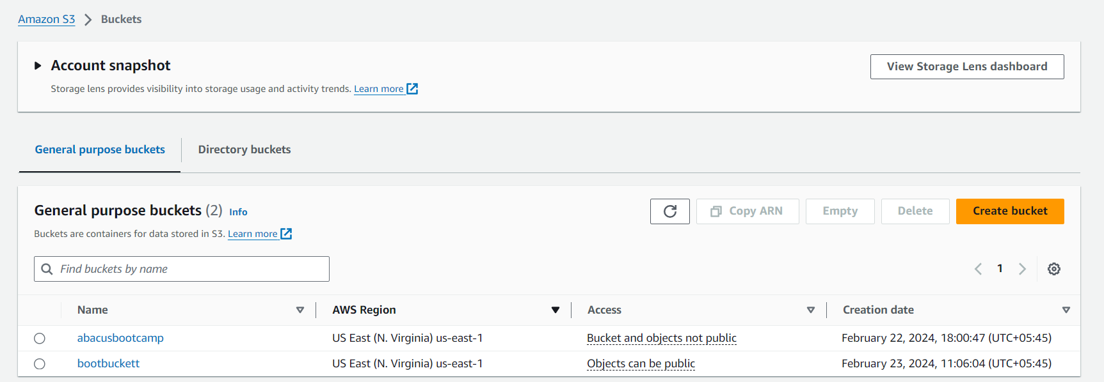

Upload a html file in the s3 bucket   
here I’m going to use bootbuckett

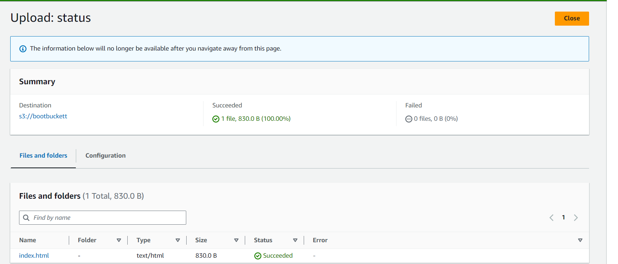

Now, Enable static website hosting as

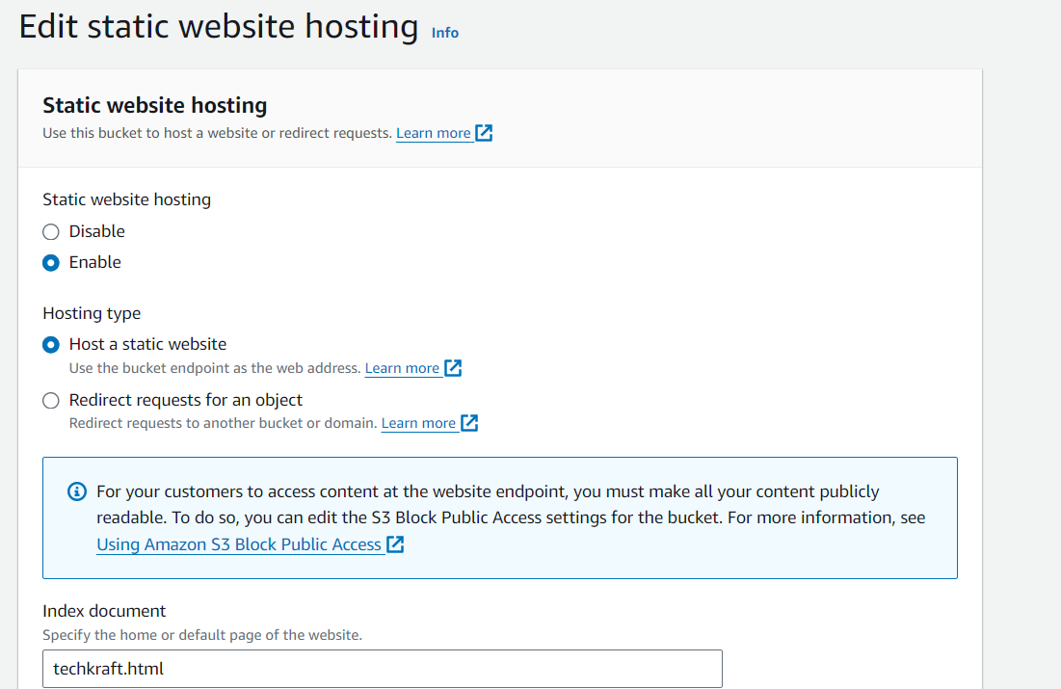

Editing the bucket policy and adding policy as

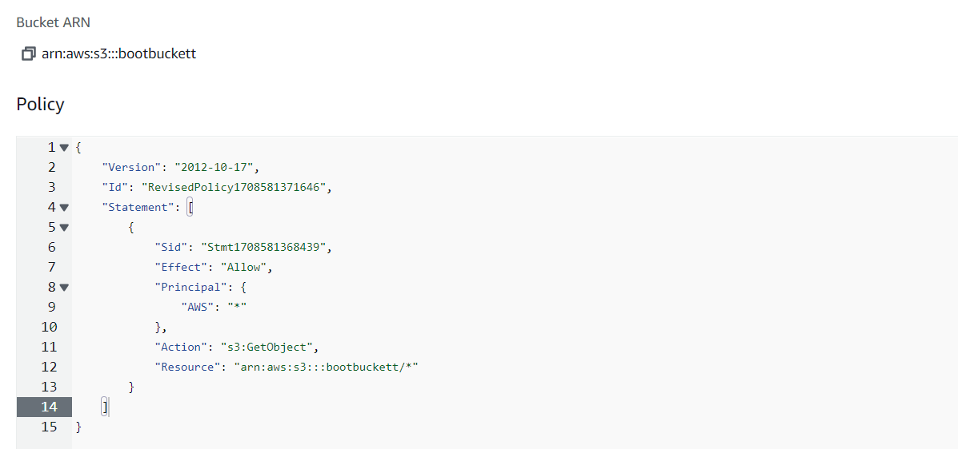

Now, here is the link for the static website that is hosted

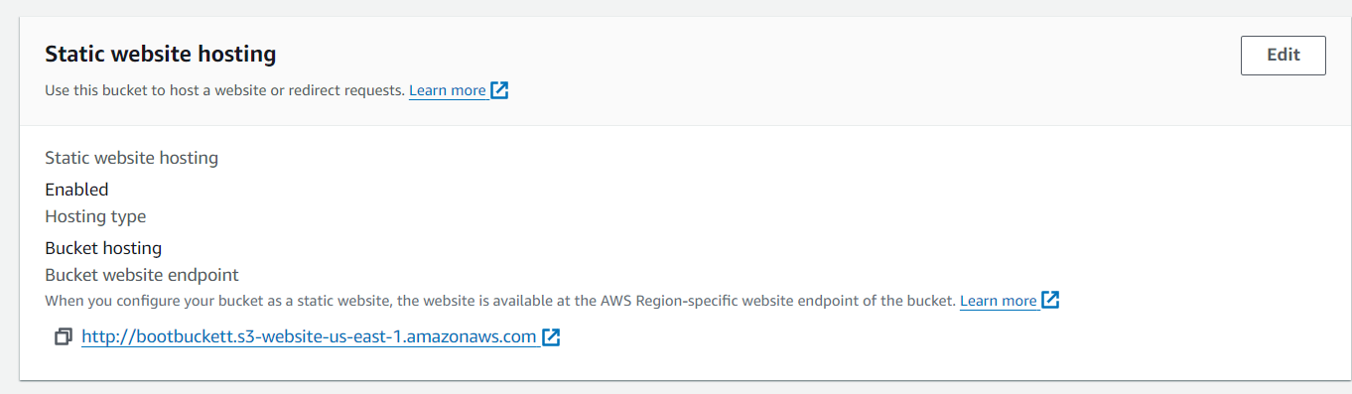

And, the result is as

